**COMPUTER ANIMATIONS**

**EARLY YEARS OF ANIMATION 1940S-1970S**

* **John Whitney**

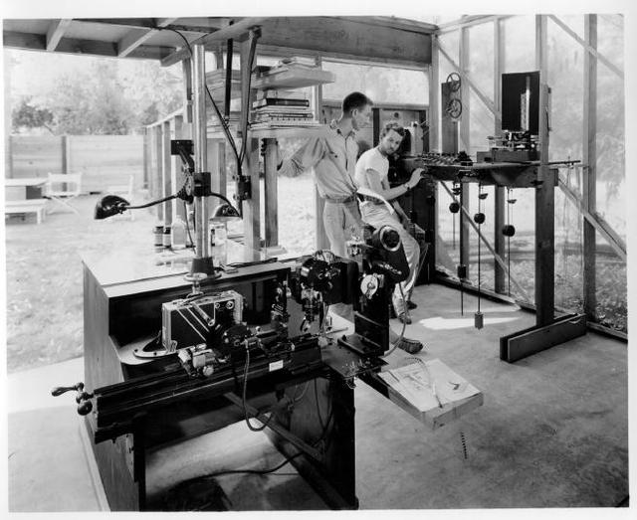

Whitney built his first analogue computer in the late 1950s when he converted a World War II M-5 anti-aircraft gun director to create a complex drawing machine. This instrument gave him the ability to explore the world of motion and movement in a new kind of abstract space powered by computers.

The customized gun was able to control cameras that would maneuver above the artwork and, astoundingly, perform the kinds of functions that would later be common on digital computers. With these bespoke machines Whitney could create a peerless type of art while keeping ahead of the computing technology of the time. And, while his machines were mechanical, they anticipated the applications of computer software which we now take for granted.

* **Ken Knowlton-Beflix**

Ken Knowlton developed the Beflix (Bell Flicks) programming language for bitmap computer-produced movies, created using an IBM 7094 computer and a Stromberg-Carlson 4020 microfilm recorder. Each frame contained eight shades of grey and a resolution of 252 x 184. in 1963, Instead of raw programming, Beflix worked using simple "graphic primitives", like draw a line, copy a region, fill an area, zoom an area, and the like.

Knowlton worked with artists including Stan VanDerBeek and Lillian Schwartz. He and VanDerBeek created the Poem Fieldanimations. Knowlton also created another programming language named EXPLOR (Explicit Patterns, Local Operations and Randomness).

* **Ivan Sutherland- Sketchpad 1**

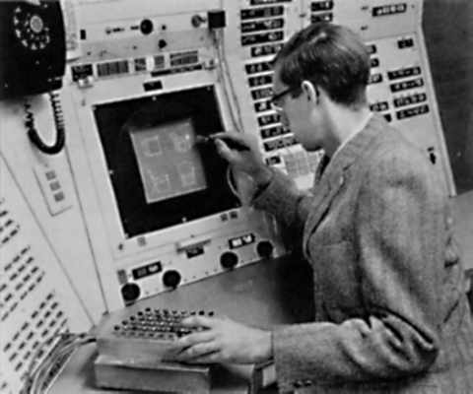

Ivan Sutherland is considered by many to be the creator of Interactive Computer Graphics, and an internet pioneer. He worked at the Lincoln Laboratory at MIT in 1962, where he developed a program called *Sketchpad I*, which allowed the user to interact directly with the image on the screen. This was the first Graphical User Interface, first non-procedural programming language, the first object oriented software system and is considered one of the most influential computer programs ever written by an individual.

* **Evans & Sutherland**

Evans & Sutherland is a pioneering American computer firm in the computer graphics field. They first produced a hardware device known as a frame buffer which, as research and commercial use of graphics grew, began selling well in the early 1970s.

* **First computer animated character,-Nikolai Konstantinov**

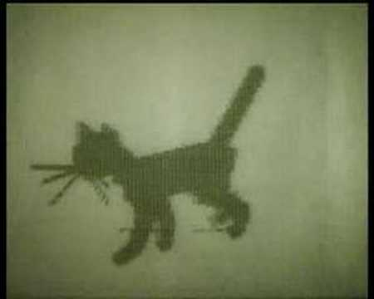

In 1968 a group of soviet physicists and mathematicians with N.Konstantinov as its head created a mathematical model for the motion of a cat. On a BESM-4 computer they devised a programme for solving the ordinary differential equations for this model. The Computer printed hundreds of frames on paper using alphabet symbols that were latter filmed in sequence thus creating the first computer animation of a character, a walking cat.

* [**Alan Kitching**](https://en.wikipedia.org/wiki/Alan_Kitching)**-Antics**

The Antics 2-D Animation software is a proprietary vector-based 2-D application for animators and graphic designers, running under Microsoft Windows. It was created in 1972 by Alan Kitching, the British animator, graphic designer, and software developer. From 1977 to 1998 the Antics software was continuously developed, and was widely used by many studios around the world.

**History of 3D Animation**

**3D ANIMATION SOFTWARES**

The 80s saw the appearance of many notable new commercial software products:

* **Autodesk Inc. – 3D Studio**
* **Softimage**
* **Side Effects Software**

Other notable softwares in 1990as and2000s:

* **Autodesk Maya**
* **Blender**
* **Cinama4D**

3D animation is a process that involves taking fully 3D objects (whether they are physical or digital) and making them animate and move. Most 3D animation today is done using CGI (computer-generated imagery). The first cinema feature movie to make extensive use of solid 3D CGI was Walt Disney's Tron. Although it has been used in films since the 1980s, it wasn’t used in large quantities until 1995, when Pixar Animation Studios released the first all-CGI film ever made, Toy Story.

# **CGI-COMPUTER GENERATED IMAGERY**

CGI  is the application of [computer graphics](https://en.wikipedia.org/wiki/Computer_graphics) to create or contribute to images in art, printed media, video games, films, television programs, commercials, videos, and simulators. The visual scenes may be dynamic or static, and may be two-dimensional (2D), though the term "CGI" is most commonly used to refer to [3D computer graphics](https://en.wikipedia.org/wiki/3D_computer_graphics) used for creating scenes or special effects in films and television.

## **CGI in the 1990s**

## **Flocking:**

[Flocking](https://en.wikipedia.org/wiki/Flocking_(behavior)) is computer model of coordinated animal motion such as bird flocks.  The mathematical model of flocking behavior was first simulated on a computer with an artificial life program devoloped by [Craig Reynolds](https://en.wikipedia.org/wiki/Craig_Reynolds_(computer_graphics)) in 1986, and soon started to be used in animation.

JURRASSİC PARK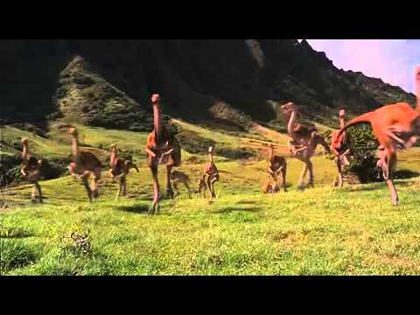

BATMAN RETURNS

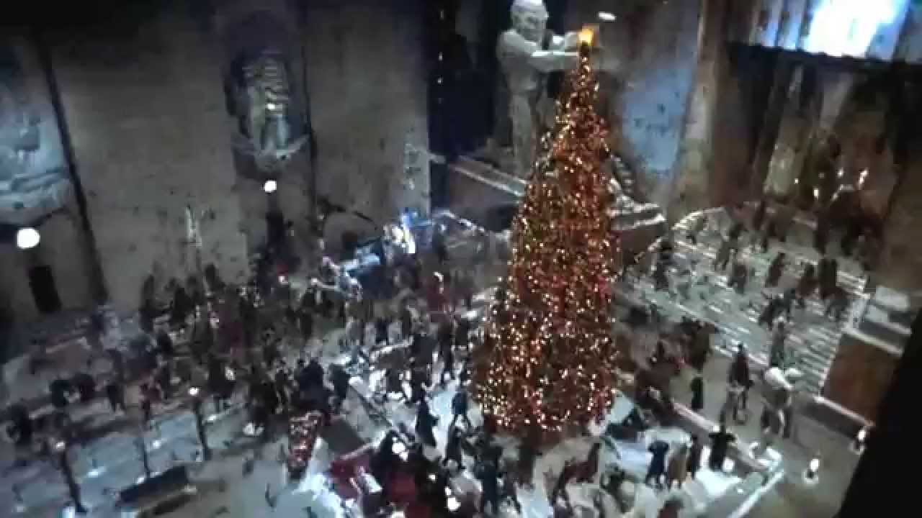

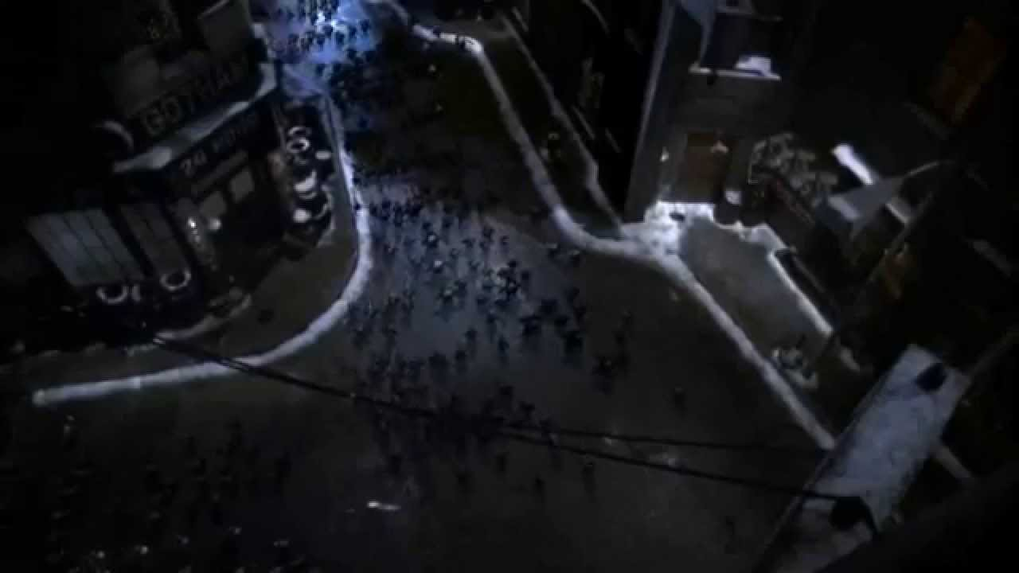

In the film Batman Returns a horde of large black bats is an greet example of flocking behavior.A single bat was created and copied by the dozens. Then each bat was instructed to move about on its own with some simple rules encoded into an algorithm: do not bump into another, keep up with neighbors, do not stray too far.

* **Motion capture:**

[Motion capture](https://en.wikipedia.org/wiki/Motion_capture), or "Mocap", is the technology that enables the process of translating a live performence into a digital performence with collecting data that represents motion.

Computer-based motion capture started as a photogrammetric analysis tool in biomechanics research in the 70s and 80s. A performer wears markers near each joint to identify the motion by the positions or angles between the markers. Many different types of markers can be used—lights, reflective markers, LEDs, infra-red, inertial, mechanical, or wireless RF—and may be worn as a form of suit, or attached direct to a performer's body. In the 90s, these techniques became widely used for visual effects. Video games also began to use motion capture to animate in-game characters in 1995, the earliest examples of this Highlander: The Last of the MacLeods and Soul Edge, which was the first video game to use passive optical motion-capture technology.

Another breakthrough where a cinema film used motion capture was creating hundreds of digital characters for the film Titanic in 1997. The technique was used extensively in 1999 to create Jar-Jar Binks in Star Wars Episode I: The Phantom Menace.

* **Match moving(motion tracking/camera tracking):**

Match moving ,unlike to motion capture, instead of using special cameras and markers to record the motion, uses pre-existing live-action footage and computer software to track specific points in the scene. Therefore, allows the insertion of CGI elements into the shot with correct position, scale, orientation, and motion relative to the existing material. The technique can be 2D or 3D, and can also include matching for camera movements. The earliest commercial software examples being 3D-Equalizer from Science.D.Visions and rastrack from Hammerhead Productions.

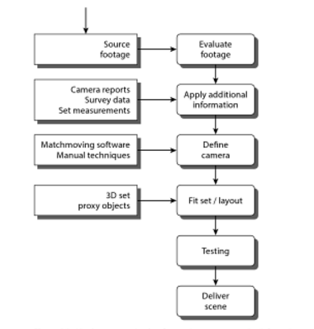

* **Virtual studio**

In television, a virtual studio, or virtual set, is a studio that allows the real-time combination of people or other real objects and computer generated environments and objects in a seamless manner.

Virtual studios, mostly include the following components:

* Camera tracking, that uses either optical or mechanical measurements to create a live stream of data describing the exact perspective of the camera.
* Realtime rendering software, that uses the camera tracking data and generates a synthetic image of a television studio.
* A video mixer, which combines the video from the camera with the video from the realtime rendering software to produce a final video output. One of the most common ways to mix the video to replace a[chroma key](https://en.wikipedia.org/wiki/Chroma_key) background.

The first practical system of this kind being the Synthevision virtual studio developed by the Japanese broadcasting corporation NHK (Nippon Hoso Kyokai) in 1991, and first used in their science special, Nano-space.

## **CGI in the 2000s**

* 2000 breakthrough capture of the reflectance field over the human face.A team led by Paul Debevec managed to adequately capture and simulate the reflectance field over the human face.
* **Motion capture:**

The first mainstream cinema film fully made with motion capture was the 2001 Japanese-American Final Fantasy: The Spirits Within ,which was also the first to use photorealistic CGI characters The film was not a box-office success.Some commentators have suggested this may be partly because the lead CGI characters had facial features which fell into the "uncanny valley".In 2002, Peter Jackson's The Lord of the Rings: The Two Towers was the first feature film to use a real-time motion capture system, which allowed the actions of actor Andy Serkis to be fed direct into the 3D CGI model of Gollum as it was being performed.

* **Virtual cinematography:**

Virtual cinematography is the set of [cinematographic](https://en.wikipedia.org/wiki/Cinematography) techniques performed in a [computer graphics](https://en.wikipedia.org/wiki/Computer_graphics) environment.

The early 2000s saw the advent of fully virtual cinematography with its audience debut considered to be in the 2003 movies Matrix Reloaded and Matrix Revolutions with its digital look-alikes so convincing that it is often impossible to know if some image is a human imaged with a camera or a digital look-alike shot with a simulation of a camera.

John Whitney opened the period of computer animation and he was soon followed by K. Knowlton, I. Sutherland and A. Kitching who made significant contributions to the world of animation. This world advanced in a short span of time owing to notable software products and progress made in computer generated imagery. CGI made it possible to create of modify images using computer algorithms. Technics such as motion capture, match moving, virtual studio and virtual cinematography converted the world opened by Whitney to modern-day computer animation.